A Project report on

**PATROLLING ROBOT**

Submitted in partial fulfilment of the requirements for the degree of

Bachelor of Technology

# in

Mechanical Engineering

Submitted by

Mr. Pratik Haribhau Rohane (17111171)

Mr. Jiganesh Ramesh Patil (17111004)

Mr. Varun Vinayak Vaidya(17111182)

Mr. Ramesh Kondiba Yedage (17111184)

Mr. Gulab Suryakant Rathod (17111024)

Mr. Swatantrya Vittal Wadar (17111183)

Under the guidance of

**Mr. G.N. Rakate**



**DEPARTMENT OF MECHANICAL ENGINEERING**

**ANNASAHEB DANGE COLLEGE OF ENGINEERING AND TECHNOLOGY, ASHTA.**

**2020-2021**

|  |  |  |  |  |  |  |  |  |  |  |  |  |  |  |  |  |  |  |  |  |  |  |  |  |  |  |  |
| --- | --- | --- | --- | --- | --- | --- | --- | --- | --- | --- | --- | --- | --- | --- | --- | --- | --- | --- | --- | --- | --- | --- | --- | --- | --- | --- | --- |
| **D E C L A R A T I O N**  We hereby declarethat, the work reported in this project report entitled **‘PATROLLING ROBOT’** which is being submitted in partial fulfilment of the requirements for the award of the Degree of Bachelor of Technology in Mechanical Engineering from Annasaheb Dange College of Engineering, Ashta has not been submitted to any University or Institution for the award of any degree.  Place : Ashta  Date :   |  |  |  | | --- | --- | --- | | **Name of Student** | **URN.** | **Sign** | | Mr. Pratik Haribhau Rohane | 17111171 |  | | Mr. Jiganesh Ramesh Patil | 17111004 |  | | Mr. Varun Vinayak Vaidya | 17111182 |  | | Mr. Ramesh Kondiba Yedage | 17111184 |  | | Mr. Gulab Suryakant Rathod | 17111024 |  | | Mr. Swatantrya Vittal Wadar | 17111183 |  |   **C E R T I F I C A T E**  This is to certify that the project report entitled **‘ PATROLLING ROBOT ’** submitted by  Mr. Pratik Haribhau Rohane (17111171)  Mr. Jiganesh Ramesh Patil (17111004)  Mr. Varun Vinayak Vaidya(17111182)  Mr. Ramesh Kondiba Yedage (17111184)  Mr. Gulab Suryakant Rathod (17111024)  Mr. Swatantrya Vittal Wadar (17111183)  as the record of the project work carried out by them, is accepted as the ProjectReportin partial fulfilment of the requirements for the award of degree of Bachelor of Technology in Mechanical Engineering from Annasaheb Dange College of Engineering, Ashta, during the academic year 2020- 2021.  Place: Ashta  Date:  Date   |  |  |  | | --- | --- | --- | | (Mr. G.N. Rakate)  GUIDE |  | HEAD OF DEPT. | | DIRECTOR |  | EXTERNAL EXAMINER | |

**A C K N O W L E D G E M E N T**

We student of Mechanical Engineering of B.Tech Final Year from Annasaheb Dange College of Engineering and Technology, Ashta would like to express our sincere gratitude to our guide Mr. G. N. Rakate for providing their invaluable and precious guidance, and suggestions throughout the course of the project till its completion. We would specially thank Mr. A. S. Dabhole for constantly motivating and pushing us to work harder.

We are also grateful for all the assistance of the workshop given, and for permitting us to have some help from them. We would also like to thank all of the faculty members of all other respective departments for their cooperation throughout the period of project completion.

We are also grateful to our parents and friends for their constant motivation and encouragement and for helping all of us in our endeavor. Last but not the least, we would like to thank everyone who has contributed to the successful completion of our Project.

**P R O B L E M S T A T E M E N T**

**Background:**

In Commercial and Industrial environment need for security patrols have increased due to population increase and widespread crime. Commercial and Industrial giants desiring to protect their physical and intellectual property have implemented human security patrols inside their buildings to prevent theft or property damage activities. Patrolling Robots were used initially for such situation earlier. Still in the midst of COVID Pandemic, many people do not follow distancing rules even with much care taken and extra personal appointed to get attention to such matters. Patrolling Robot can be implemented with unique modifications to this situation

**Problem Statement**

As Humans can get fatigued and can eventually get tired or bored out of their jobs they can become inattentive to details within their environment. Human Lives would be in grave danger if faced with criminal activity or any deadly occurrence during patrolling. To avoid such damage to Human Life and Property many alternatives are explored for Patrolling Areas. As we see people around crowding up place it should be notified to the authority immediately to avoid future damage to any lives and a patrolling robot should be able to handle this situation with real time monitoring and patrolling the whole area and sending alerts when required.

**A B S T R A C T**

Patrolling Robots can patrol periodically as instructed in the instructed area to ensure the safety and avoid crowd, because of COVID pandemic such technologies will provide aid in crowded places creating awareness and ensuring safety. The proposed autonomous vehicle robot cannot only save manpower, but can also ensure the performance without mistakes caused by man and giving higher efficiency in work. Patrolling Robot is designed and developed in such way that it would give higher efficiency and can be flexible at the same time.

This robot represent an approach to improving the autonomous system which will provide on demand services like transport and surveillance. This robot will be with ability to detect obstacles in its way and make its own route which will be obstacle free path. Development of a custom trained autonomous robot which is capable to optimising its own route through the input given by user.

The second objective of our project is to to build the Human Detection and Counting System through Webcam, videos or images. The system will be used in Patrolling Robot to detect and count pedestrians with through Pi Camera. The system uses computer vision and image processing methods to implement the project.

**S O L U T I O N**

SUMMARY:

In the situation where least human involvement is required and where safer, efficient, cost-effective solutions are admired, robots are often been used. Robots can keep up constant alertness as they don’t get tired or grow bored of their work or instruction given. Due to their efficiency, low cost and ability to move fast through a known environment, autonomous vehicles/robots are a cost-effective solution in monitoring buildings for such purposes and can protect valuable human lives. All of the obstacles have been tackled and some of those tasks have been implemented, but this is the very first time when all of it has been brought together as one complete system.

For the Intended final result by the robot, this project is broken down to five basic important objectives.

1. Patrol in unknown environment.

2. Avoid Obstacles.

3. Detect Humans in surroundings.

4. If Humans are detected above the given threshold count

5. Alert the authority.

For the five basic objectives, the built prototype should demonstrate and show satisfactory results. The whole Patrolling Robot System should complete and pass through all tests which are implemented on it.

**INDEX**

|  |  |  |  |
| --- | --- | --- | --- |
| **Chapter** | **Sub-Chapter** | **Content** | **Page No.** |
|  |  |  |  |
| 1 |  | **Introduction** | 1 |
|  |  |  |  |
| 2 |  | **Proposed Implementation** | 2 |
|  | 2.1 | Hardware | 2 |
|  | 2.2 | Design | 3 |
|  | 2.3 | Software | 6 |
|  |  |  |  |
| 3 |  | **Algorithms and Logic** | 7 |
|  | 3.1 | Algorithm | 7 |
|  | 3.2 | Working Logic | 7 |
|  | 3.3 | Programming Logic | 7 |
|  | 3.4 | Parameters | 8 |
|  |  |  |  |
| 4 |  | **Path Planning and Object Avoidance** | 9 |
|  | 4.1 | Framework of Navigation | 9 |
|  | 4.2 | Object Avoidance | 10 |
|  | 4.3 | Working Process | 11 |
|  |  |  |  |
| 5 |  | **ROS simulation** | 12 |
|  |  |  |  |
| **Chapter** | **Sub-Chapter** | **Content** | **Page No.** |
| 6 |  | **Human Detection** | 15 |
|  | 6.1 | Proposed Implementation | 15 |
|  | 6.2 | Programming Logic | 15 |
|  | 6.3 | Required Libraries | 15 |
|  | 6.4 | Algorithm for Human Detection | 16 |
|  | 6.5 | Working Method | 17 |
|  | 6.6 | Working Output | 18 |
|  |  |  |  |
| 7 |  | **Future Enhancements** | 19 |
|  |  |  |  |
| 8 |  | **Conclusion** | 20 |
|  |  |  |  |
| 9 |  | **References** | 21 |

**1. Introduction**

To aid human lives and perform tasks in efficient manner in pandemic environment new robotic technologies and new implementations using those are highly encouraged. To help with task like patrolling, monitoring and security this robotic solution is proposed. This Autonomous Patrolling Robot system performs task like patrolling, monitoring and enforcing the security of the environment. According to all the functionalities it has shown the project prototype is called (Autonomous) Patrolling Robot.

Currently world is facing COVID 19 Pandemic to aid humankind many technologies are used to ensure safety. Proposed Robot has an Autonomous System and Human Detection based Crowd Alert System. It represents an approach to improving the autonomous vehicle system, which will provide on demand services like transport and food delivery, etc. The patrolling robot will have ability to detect obstacles in its way as its first objective and find path which will be obstacle free path. Development of a custom trained autonomous robot which is capable to optimising its own route through the input given by user.

The other goal of the project is to build the Human Detection and Counting System through Webcam, Videos or Images. The system will be used in Patrolling Robot to detect and count pedestrians with through Pi Camera. The system uses computer vision and image processing methods to implement the project. By considering the count of people it will alert whether the place is crowded or not. Hence the Robot will possess an Autonomous path planning and Human Detection Algorithm.

**2. Proposed Implementation**

2.1 Hardware

* **Power Supply/ Battery charger:** Battery is rated as 11.4 V, 2500 mAh powering up the entire circuit of the robot. Batteries can be charged with power supply user-adjustable voltage and current limiting. A power supply is usually designed to supply constant voltage (V) to a load (L). A battery charger generally supplies regulated current and charges battery and switches to regulated voltage mode
* **GPS Module:** A GPS also known as Global Positioning Module provides the latitude and longitude data. The Patrolling Robot uses the Ublox Neo module, a GPS module which contains micro-processors and antennas that receive data sent from satellites through dedicated Radio frequencies.
* **Digital Compass:** Digital compass have an embedded micro controller that usually subtracts the weaker magnetic field from the stronger earth magnetic fields giving in accurate and precise compass reading. HMC5883L 3-axis digital compass connected with Arduino at SDA and SCL pin to get Heading is used.
* **Ultrasonic Sensor:** By emitting sound waves and converting the reflected sound into an electrical signal from the distance measured by target object is how an electronic device like ultrasonic works. The Ultrasonic Sensor used specifically here is HC-SR04. It is used to detect obstacle in front of the robot and to help avoid that obstacle.
* **Motor Driver:** Motor drivers acts like an interface between the 2 motors and the control circuits. A DC Motor requires high amount of current and the controller circuit works on low current signals. L298 Motor Driver is used for the driving of motors, which operate on the Arduino signal is used for prototype.
* **Raspberry Pi:** It is a series of small and single-board computers. Raspberry Pi is also a Linux based cheap computer available, but it provides a set of GPIO (general purpose Input/output) pins that helps to control electronic components for physical computing and IOT. It is used in Patrolling Robot for Human detection through PI camera which can be looked up as the extension of Raspberry Pi
* **Pi Camera:** A Pi Camera is high resolution quality 8 MP SONY INX219 image sensor which is custom designed, add-on board for Raspberry Pi, featuring a fixed focus lens for better performance. It is used to capture the real time image in its range and with processing that image the algorithm will be able to detect Humans in the environment.

2.2 Design

Robot Chassis

A 5mm thick plastic board has been used to build structure of the robot (dimension 18 cm * 12 cm).  Robot chassis is used as a mounting platform of hardware components. All the electronics hardware is placed on the platform. The robot motion is control through the 4 DC motors which operate on the Arduino instructions. These motors are attached to the chassis with the help of a motor bracket chip and tighten with the nut and bolt. On the top of chassis, the Arduino board is mounted centrally. The battery is placed on the back motor so the steering can easily be done. The less weighted component is on the top layer of the robot platform. The ultrasonic sensor is at the front side of the robot at the bottom layer.

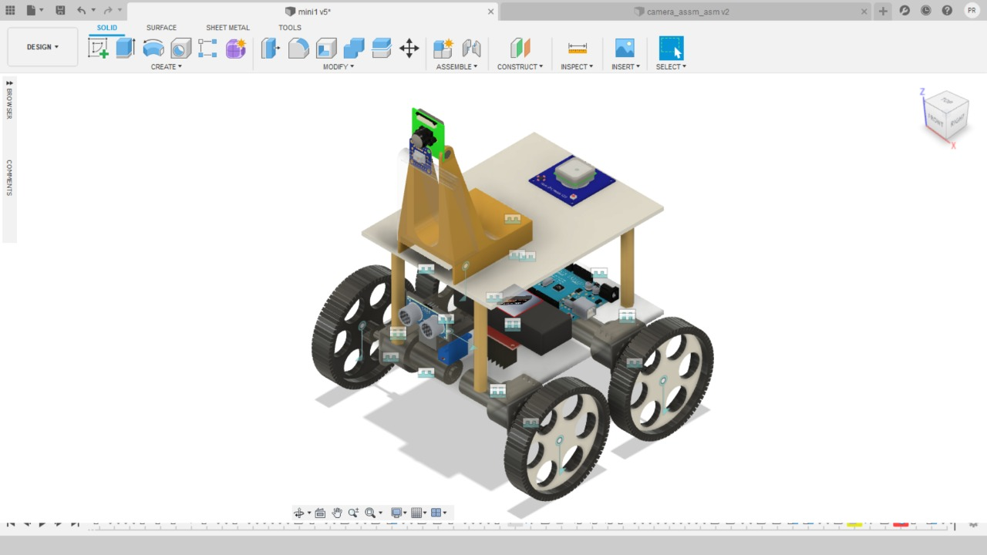

Fig 2.2.1 Patrolling Robot designed in Fusion 360

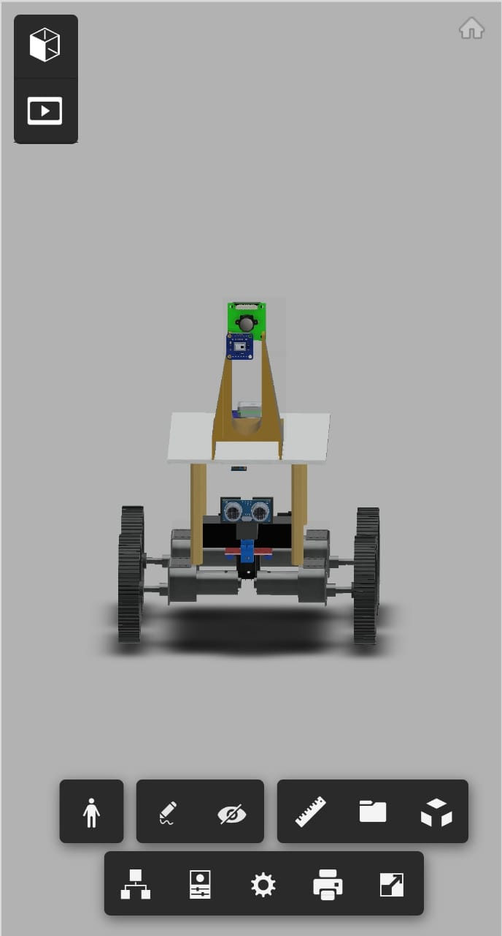  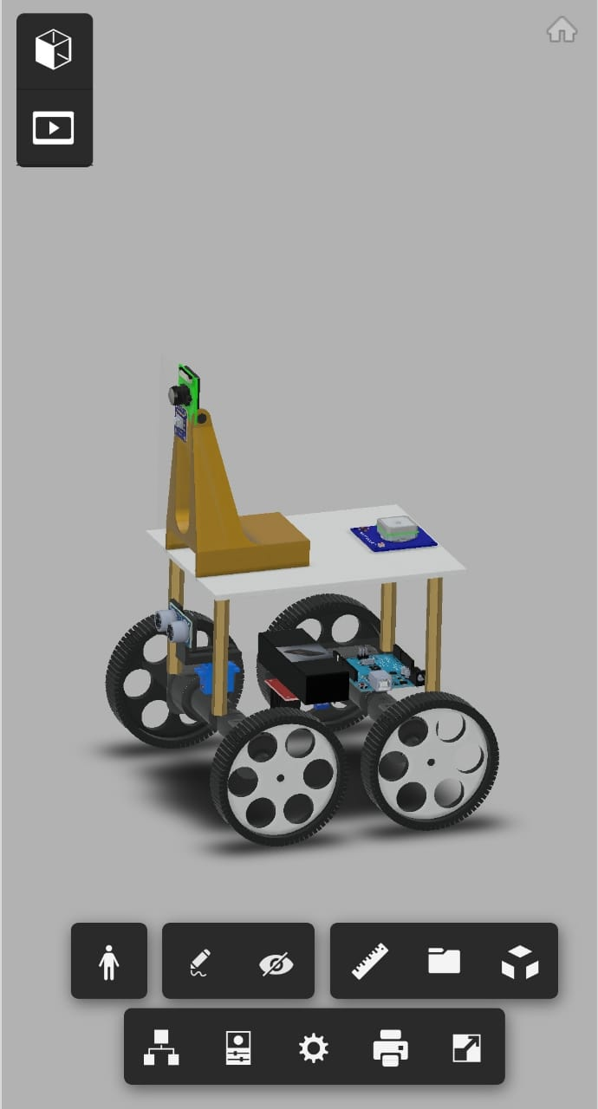

Fig 2.2.2 Patrolling Robot Front View Fig 2.2.3 Patrolling Robot Side View

Motor Speed Control and Motor Drivers:

Robot motor speed is control using PWM (Pulse Width Modulation) functionality available in the Arduino. It allows to partially power the motor through controlling the duty cycle of the power signal. Robot motor speed is control using PWM (Pulse Width Modulation) functionality available in the Arduino. It allows to partially power the motor through controlling the duty cycle of the power signal. Motor drivers acts as an affiliate between the 2 motors and the control circuits. A DC Motor requires high amount of current and the controller circuit works on low current signals. L298 Motor Driver for the driving of motors, which operate on the Arduino signal is used for prototype.

The programming logic in speed controlling

∙ If robot moving straight and no object >>> fast speed

∙ If robot moving straight and object detect >>> slow done speed

∙ If robot is turning >>> slow down to intermediate speed

Arduino

Arduino is an open-source electronics platform based on easy-to-use hardware and software. They can read inputs and interact with user and provide output. Arduino is used to interact with GPS, Digital Compass, and Ultrasonic Sensor.

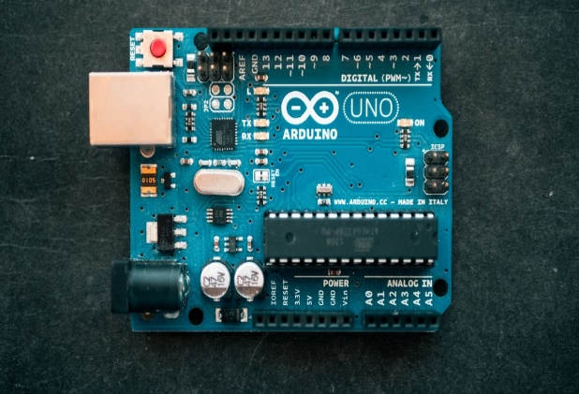

Fig 2.2.4 Arduino Board

Raspberry Pi

A Raspberry Pi is small processor that can easily connect to the Internet and Interface with a lot of hardware component. Raspberry is used because it is small and perfect for embedding it on your robot. It is cheap and powerful. Raspberry Pi is used to work with Pi Camera and help with processing data for Human Detection.

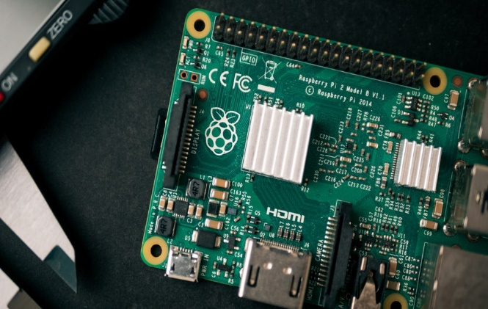

Fig 2.2.5 Raspberry Pi Board

2.3 Software

* **GPS Module Interfacing:** GPS helps for receiving valid latitude and longitude data. At least connection with three satellites is required to communicate with the module. The set of data we receiver is in NEMA strings. To extract useful data like latitude and longitude, library name ‘TinyGPS.h’ for the Arduino is used. The library is used in Arduino to help communicate positioning data with GPS Sensor
* **Digital Compass Interfacing:** For Heading Angle Calculation (HAC) a Digital Compass is used in the patrolling Robot. I2C communication protocol is used by the digital compass. To achieve I2C communication with Arduino ‘wire.h’ library is used.
* **Ultrasonic Interfacing:** Ultrasonic Sensors are used for Obstacle detection and Avoidance hence libraries needed for ultrasonic interfacing are used with Arduino.
* **Python and OpenCV:** Python is used for human detection algorithm with its Open CV library.

1. **Algorithm and Logic:**

3.1 Algorithm

For the robot to move, the algorithm starts by finding the target direction. This can be done by the calculating initial angle by digital compass and target angle between the initial position and final position of GPS coordinates. The final position coordinate is given define initially by the user. The current coordinate is taken from the GPS Module.

The set of the coordinate pass into the function which returns angular position over the robot rotate accordingly and linear displacement. After turn into a targeted direction, robots start moving in the forward direction. And every second the new position of the robot is to consider as the initial position and GPS coordinate of respective position send into the same faction to calculate the angular position and linear displacement. This loop continuously operates until the reach to the desired location.

While moving the ultrasonic sensor continuously bursts the signal as the object cone into the safe distance, the robot slows down the speed. Turn in the direction near to the final position. As the path is free from the obstacle start again operating on the above algorithm.

3.2 Working Logic

1. GPS Module Read Current Location

2. Compass Read Current Heading Angle

3. Align to Target Angular Position (minimize error)

4. Every Second Repeat above Steps

5. As Difference of two Locations below Threshold, Robot Break to that point.

3.3 Programming Logic:

1. User provide the GPS coordinate destination point on the user interface.

2. Robot take its current GPS coordinate which are initial point of the robot.

3. Targeting the distance between these two points and direction.

4. Turn in that direction and move to the next waypoint.

5. Trying to minimising the distance by continuous point to point steering approach.

* 1. Parameters to Determine

1. **Target Heading:** Direction of final point from the initial point.
2. **Current Heading**: Direction of robot facing initially.

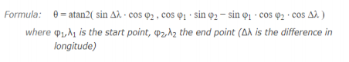

1. **Error (degree):** Error between the target heading and current heading. This is signed value (+/-) which indicated the direction (left/right) to turn of robot.
2. **Distance:** Distance between the Final point and Initial point, which changes continuously as robot move.

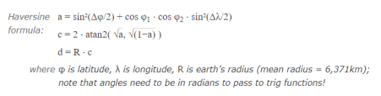

5. **Obstacle Distance:** Distance from the robot to the object in front of it.

6. **Speed of Robot:** Speed of robot are in arrange (0-255).

Current heading

Target Heading

Speed of Robot

**Parameters to determine**

Error (degree)

Obstacle Distance

Distance

Fig 3.4.1 Parameters for Path Planning

**4. Path Planning**

It is a very difficult task to find the optimizing path for the robot to travel. As there are ‘n’ no. of the cluster can be found in the global environment. We are come up with the simple algorithm of path planning. The Algorithm takes start and end points and with the logic above it performs various iterations to get to his target.

4.1 Framework of Navigation:

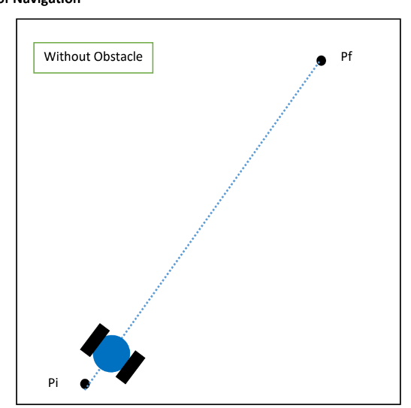

Fig 4.1.1 Path without obstacle

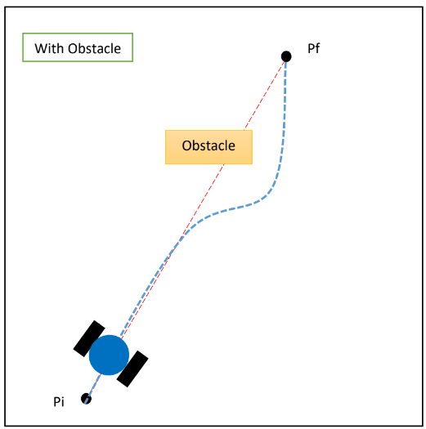

Fig 4.1.2 Path with obstacle

4.2 Object Avoidance

To drive robot fully autonomous object avoidance is the main feature in all. Determining the presence of the obstacle in front of the robot. Ultrasonic HS-05 Sensor is used to detect the object’s presence and position of the object from the robot. Ultrasonic Sonic sensor is at the front of the robot which tends to return the distance from the object. The program has set the safe distance if within which the object detect the robot follow the instruction are given to it from the program.

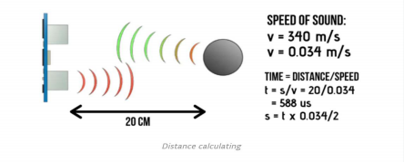

Fig 4.2.1 Ultrasonic Sensor Working

If Obstacle is detected:

* Slow done the speed
* If robot moving straight >>> Find the side to the object free from obstacle.
* If robot turning >>> Repeat the above step
* If robot is too close of object >>> Break, Reverse and Try again.

4.3 Working Process:

Initially GPS module calibrates the Initial location then it calculates the target angle with respect to the target location by its algorithm

The heading angle of autonomous patrolling robot is read by the digital compass, and then the error between Initial current heading angle and target is calculated.

Because of Proportional Controller block, with respect to error recorded the motor will get signals and will try to get in target angular position hence the error will be minimized further.

For every instance, the initial GPS location is calculated and the value of target angle is measured if any distortion in path is occurred while travelling.

The patrolling robot will align in target or desired direction by always reading value of compass.

Ultrasonic Sensor emits burst signal after 1 second to figure out the presence of obstacle.

For every instance the GPS module records the initial location and calculates the difference between initial and final location. If the calculated difference is less than threshold value given, the algorithm for the motor pulse will stop as the robot has reached to target destination and is nearby it.

**5. ROS Simulation**

The Robot Operating System is an Open-source framework that helps to build and use the code between robotics applications. The robot works inside gazebo simulation, patrolling robot performs physics calculations and generates/builds a synthetic sensor data which offers convenient allies and interfaces.

The engine which is responsible to simulate the real time physics interacts with the simulation environment to handle the patrolling robot in the simulation. It includes simulating parameters such as gravity and motion control under normal conditions. Patrolling Robot is set up with different sensor like GPS sensors, Digital Compass sensor.

A downside of this simulated sensor which are available is that they are a bit too perfect when it comes to application, this is why even you can get some unexpected result if you perform in simulation and real world so fine tuning is necessary. Types of noises are added in the generated data to just distort the return data from standard conditions

Gazebo is simulator which test’s logic, design of robots, and performs regression testing and trains Artificial Intelligence using real time environment. Gazebo provides the ability to precisely and efficiently simulate robots in all type of environments like indoor and outdoor environments.

Steps in development of Patrolling Robot simulation are:

1. Design Simulation

2. Define Motion Control

3. Train Control Policy

4. Evaluate in Reality

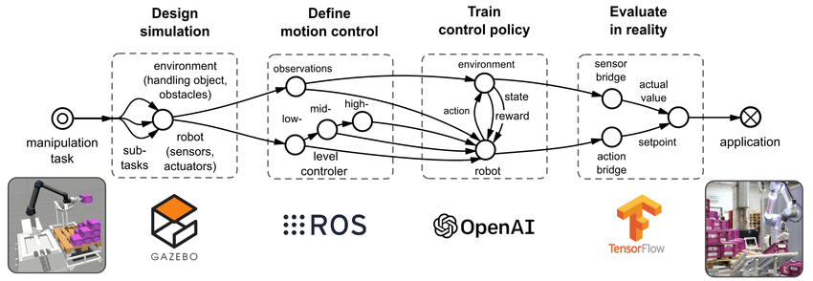

Fig 5.1 ROS Simulation Flowchart

**Environment for Path Planning and Obstacle Detection:**

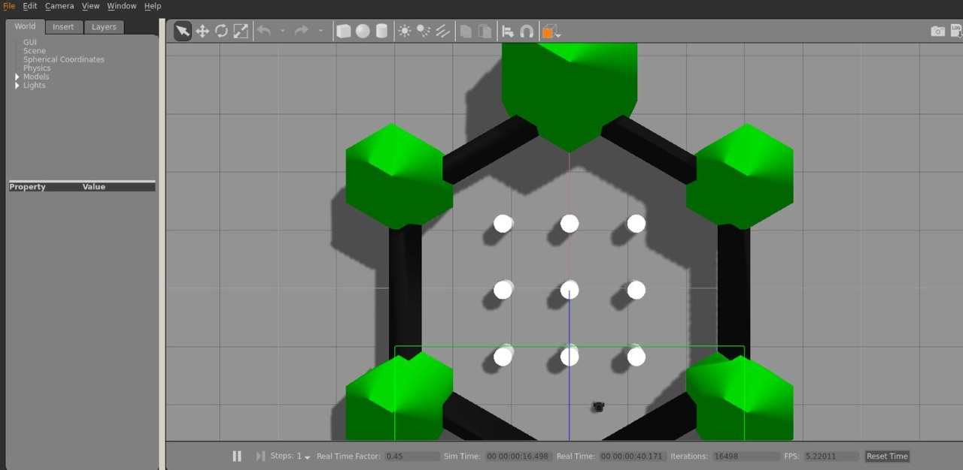

Fig 5.2 ROS Simulation for Path Planning (Top View)

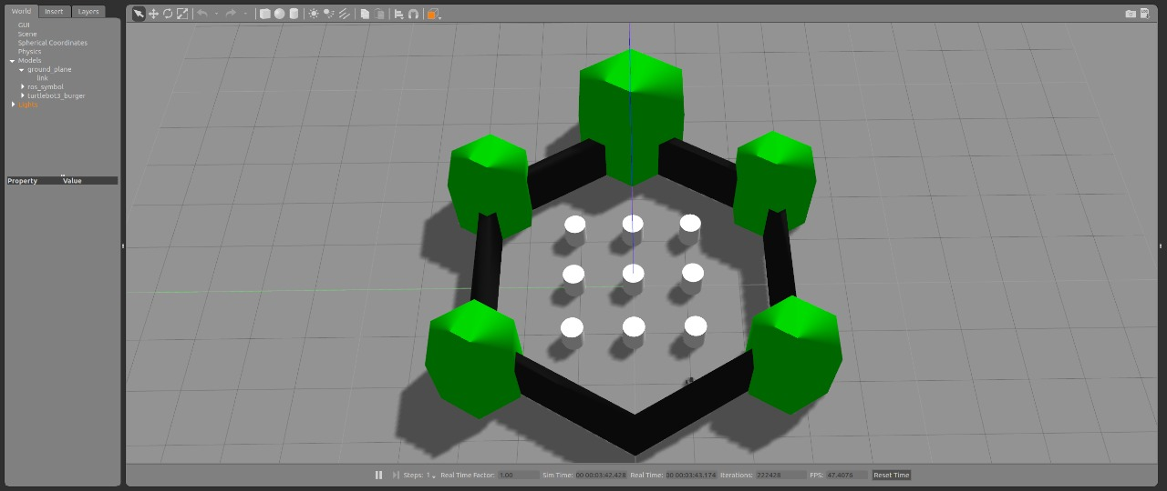

Fig 5.3 ROS Simulation for Path Planning Environment

This environment is simulated in gazebo where the black object represent the wall and boundary and white object represent the obstacles. The robot will be given respected co-ordinates and placed anywhere in the block and expected to return to end position. The robot will move through this environment reaching its destination by avoiding white obstacles.

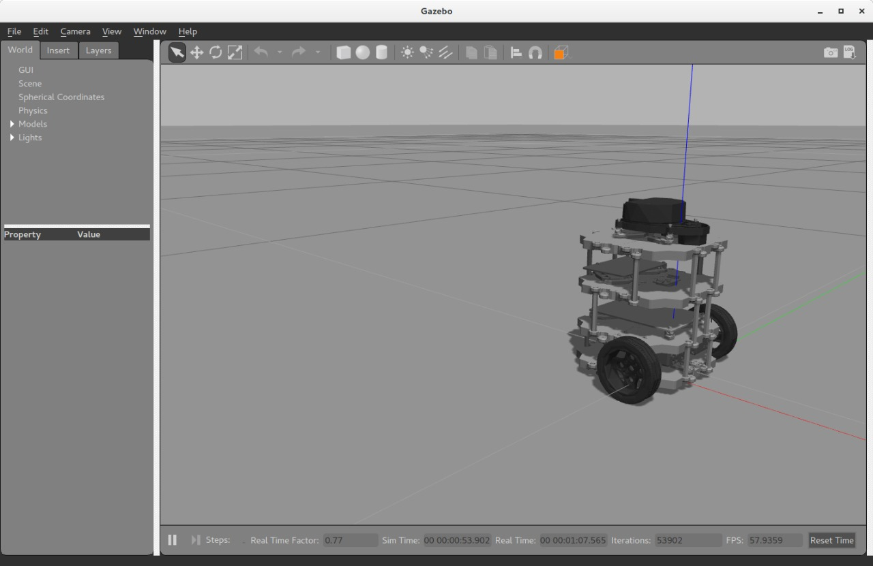

Fig 5.4 Robot built in for the simulation in GAZEBO

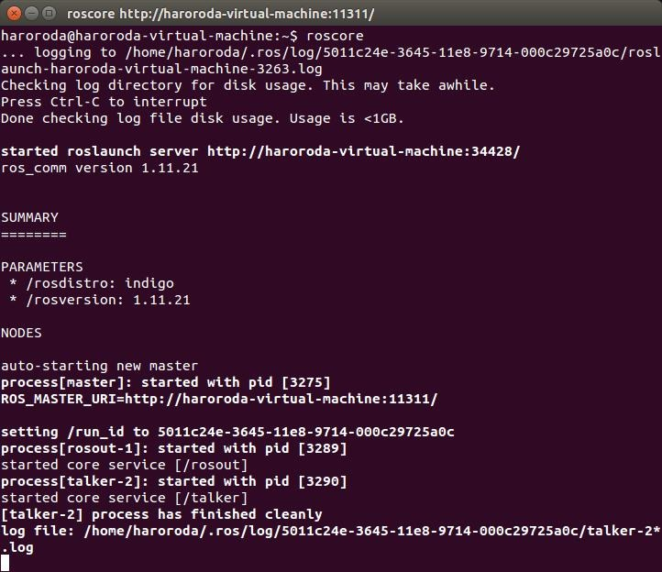

Fig 5.5 ROS Simulation Terminal

**6. Human Detection**

6.1 Proposed Implementation:

1. Detection of humans in a given frame.
2. Count the number of persons in each frame to combine in a video.

6.2 Programming Logic:

1. To elaborate good data abstraction of the human model select the descriptor methods
2. Using the Support Vector Machine Classifier train a detection model by setting positive and negative training images.
3. To remove the noise and get accurate model perform a Non-Max Suppression.

6.3 Required Libraries:

**OpenCV:** A strong library used for machine learning and a real-time optimized Computer Vision. It is open-source library for the computer vision, machine learning image processing and not it plays a major role in real-time operation.

**Inutile:** For Image Processing and non-max suppression method

**Numpy:** Numpy is a python library used for working with arrays. It is open-source and used for Image processing and Human Detection in Patrol Robot. Used for Scientific Computing. Image is stored in a Numpy array.

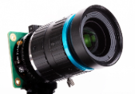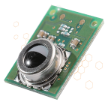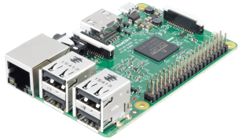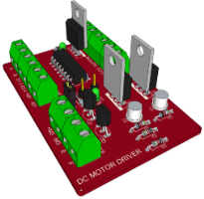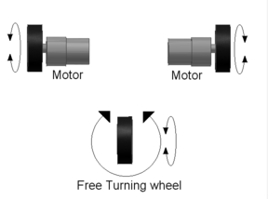

Fig 6.3.1 Connection of Hardware Flowchart

6.4Algorithm for Human Detection:

The algorithm used is HOG descriptor combined with the SVM classifier.

Histogram of Oriented Gradient (HOG):

Histogram of Oriented Gradient known as HOG is a feature descriptor, which was introduced by Dalal and Triggs. It is a technique of Object Detection which defines the shape of the object by distribution of edge Directions. Cells are the small connected regions that are obtained by dividing the images by application of descriptors. For each instance of “Cell” we calculate histogram of gradient directions or for all pixels of cell edge orientations. Descriptor are the combination of histograms

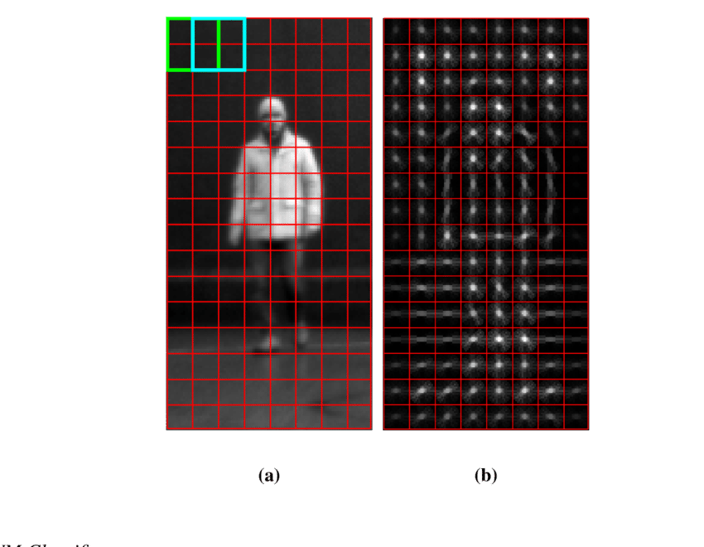

Fig 6.4.1 Gradient Algorithms

Every single pixel of the surrounding pixel is checked directly by algorithm. Among all pixels how more dark the initial pixel is to surrounding pixel is what to be found. The direction of image going darker is shown by arrows which is drawn by the algorithm itself. Process is repeated for each and every pixel for that image. Finally all pixel will be replaced by and arrow. Gradient are those arrows. Flow of light is shown by gradient form light to dark. Further analysis is performed by using these gradient algorithms.

SVM classifier

To feed the SVM classifier, which generates a model a set of descriptors are used. Support vector machines (SVM) are linear classifiers. SVMs find a line in dimensions more than or in between different classes of data so that the distance on any side of that line to the next closest data point is maximized. The process can be defined as proposed by Dalal and Triggs



Fig 6.4.2 SVM classifier Flowchart

Non max suppression

Most of multiple bounding boxes are detected while using HOG descriptor and Linear SVM for object classification. Rather returning all found bounding boxes the non-maximum suppression to ignore bounding boxes overlap.

6.5 Working Method:

The method can be broken into steps as follows:

1. Sampling positive and negative images
2. Training Linear Support Vector Machine
3. Hard-Negative Mining should be performed
4. Using Hard-Negative samples retrain Linear Support Vector Machine Algorithm
5. Evaluate your classifier on your testing data, utilize non-maximum suppression to ignore repetition and overlapping bounding boxes.
6. The code is able to detect and count the number of persons from image, video or live camera.
7. When we give input with file name with required file extension in INPUT eg.for image use '.jpg', for videos '.mp4' and for live camera put 'cam', It will give realtime number of persons in the frame.

6.6 Working Output:

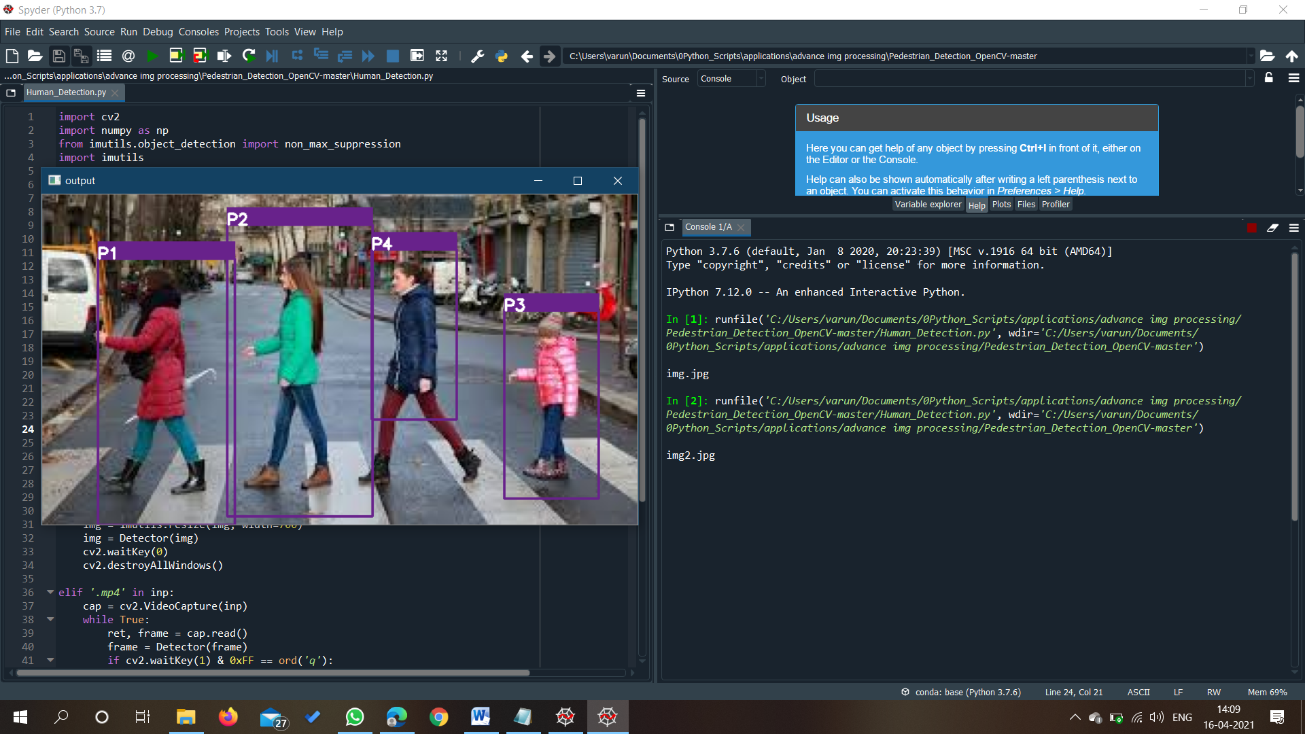

Fig 6.6.1 Output of Human Detection Algorithm applied on Image

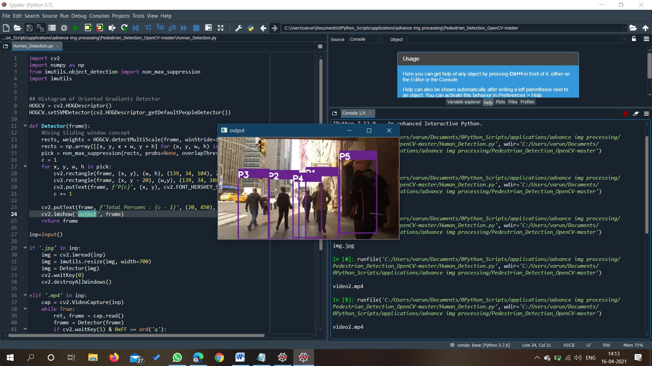

Fig 6.6.2 Output of Human Detection Algorithm applied on Video Frame

**7. Future Enhancement**

1. **Steering Mechanism for the proportional movement of wheels:** Considering the Mechanism used in steering this can be improved for proportion movement of wheels with fine tuning.

2. **Add Camera for object detection to increase accuracy:** Camera can also be configured for obstacle detection replacing it with ultrasonic sensor which can give us error if blocked by something else or if lighting conditions are not up to the mark.

3. **Web Application for user interaction with robot :** An Interface can be developed for the autonomous patrolling robot so user can interact with it giving it certain start and stop position and customizing it travelling path on the go with some web-application.

4. **Increasing Accuracy and Range of Human Detection :** Standard Machine Learning Algorithm is used to this providing Training Data and Testing Data which gives a value for Accuracy of Machine Learning Model using Confusion Matrix this value of Accuracy can be improved by figuring out right amount of Testing data and Training data.

5. **Recording Data:** We can provide a backend and record the data from our Patrolling Robot

And with this data we can predict the frequency of people and crowd at different times and improve the patrolling pattern of robot.

**8. Conclusion**

Patrolling Robot is built combining different algorithms solving different test cases with one goal to create an alert system for crowded places for social distancing. Using Patrolling Robot surveillance can be carried out in crowded places like Hotels, Schools, Shopping Malls, Theatre, Fairs, Railway and Bus Stations with less Human life involvement maintaining all given instructions. Building Patrolling Robot many Mechanical, Electronics and Computer Science Concepts were used as needed referring to all relevant research papers and available data from the Internet.

Many areas of engineering to build a robot which has human detection and Path Planning Algorithm were explored. Using Mechanical aspect of engineering chassis which was vibration proof, stable and load sustaining was built. With Electronics aspect different tasks with processors and controllers like Raspberry Pi and Arduino. Many software and programming language like python and its libraries OpenCV, Numpy for Human Detection and were used for Autonomous Human Detecting Patrolling Robot. Additional Fine Tuning was done for Real World Scenarios considering how much error was there in them.

**9. References**

1. Desavale, Ramchandrea Ganapati, Rafiq Abu Kanai, Shrirang Pandurang Chavan, Venkatachalam Rapur, and Prakash M Jadhav. “Vibration Characteristics Diagnosis of Roller Bearing Using the New Empirical Model”, Journal of Tribology, (2015).
2. Erramouspe, Jake, "Autonomous Security Patrol System" (2010). Undergraduate Honors Capstone Projects. 46.
3. H. Bingo, "Development of a Control Target Recognition for Autonomous Vehicle Using FPGA with Python," 2018 International Conference on Field-Programmable Technology (FPT), (2018), pp. 419-420, doi: 10.1109/FPT.2018.00089.
4. Megha Agarwal. “HOG feature and vocabulary tree for Content-based Image Retrieval”, International Journal of Signal and Imaging Systems Engineering, (2010).
5. M. V. G. Aziz, H. Hindersah and A. S. Prihatmanto, "Implementation of vehicle detection algorithm for self-driving car on toll road cipularang using Python language," 2017 4th International Conference on Electric Vehicular Technology (ICEVT), 2017, pp. 149-153, doi: 10.1109/ICEVT.2017.8323551.
6. P. Falcone, F. Borrelli, J. Asgari, H. E. Tseng and D. Hrovat, "Predictive Active Steering Control for Autonomous Vehicle Systems," in IEEE Transactions on Control Systems Technology, vol. 15, no. 3, pp. 566-580, May (2007), doi: 10.1109/TCST.2007.894653.
7. Somantri, Rizki Fuazi Ridwanullah, Hendra, Devi Safitri “Cigartte Smoke Detection System for Non-smoking Areas Based on IOT and Face Recognition”, 6th International Conference on Computing Engineering and Design (ICCED), (2020)



